Experiment / Case Study No.: 5
EXPERIMENT
1. Experiment Title:
To study the functioning of Arrays and Loops in JavaScript. a) Create and manipulate arrays: push, pop, shift, unshift, splice, slice. b) Use array methods: map(), filter(), reduce(), forEach().
2. Software/Tools Required:
VS Code (text editor), HTML, CSS, JavaScript.
3. Experiment Program Code:
Shopping Cart Calculator (single file: HTML + CSS + JS) –
index.html:
<!DOCTYPE html>
<html lang="en">
<head>
<meta charset="UTF-8">
<meta name="viewport" content="width=device-width, initial-scale=1.0">
<title>Shopping Cart Calculator</title>

<link rel="preconnect" href="https://fonts.googleapis.com">
<link href="https://fonts.googleapis.com/css2?family=Space+Mono:wght@400;700&family=Archivo+Black&display=swap" rel="stylesheet">

<style>
:root {
--paper: #faf6ed;
--paper-dark: #f0e9d8;
--ink: #241f1a;
--ink-soft: #6b6255;
--line: #cdc3ac;
--stamp-red: #b23a2e;
--stamp-green: #3b6e4f;
--focus: #1f6f5c;
}

* {
box-sizing: border-box;
}

body {
font-family: 'Space Mono', 'Courier New', monospace;
background: #e8e2d3;
background-image:
radial-gradient(circle at 1px 1px, rgba(0,0,0,0.045) 1px, transparent 0);
background-size: 14px 14px;
color: var(--ink);
min-height: 100vh;
margin: 0;
padding: 48px 16px 72px;
display: flex;
flex-direction: column;
align-items: center;
}

.receipt {
width: 100%;
max-width: 640px;
background: var(--paper);
padding: 40px 36px 28px;
box-shadow:
0 1px 0 rgba(0,0,0,0.05),
0 24px 48px -20px rgba(36, 31, 26, 0.35);
position: relative;
}

/* torn perforated edge at the bottom of the receipt */
.receipt::after {
content: "";
position: absolute;
left: 0;
right: 0;
bottom: -13px;
height: 26px;
background:
radial-gradient(circle at 13px 0, transparent 13px, var(--paper) 13.5px) 0 -13px / 26px 26px repeat-x;
}

header {
text-align: center;
border-bottom: 2px dashed var(--line);
padding-bottom: 20px;
margin-bottom: 24px;
}

.eyebrow {
font-size: 11px;
letter-spacing: 0.35em;
color: var(--ink-soft);
text-transform: uppercase;
margin-bottom: 8px;
}

h2 {
font-family: 'Archivo Black', 'Space Mono', sans-serif;
font-size: 28px;
margin: 0;
letter-spacing: 0.01em;
}

.tagline {
font-size: 12px;
color: var(--ink-soft);
margin-top: 8px;
}

.entry-form {
display: grid;
grid-template-columns: 1fr 1fr;
gap: 10px;
margin-bottom: 10px;
}

.field {
display: flex;
flex-direction: column;
gap: 4px;
}

.field.full {
grid-column: 1 / -1;
}

label {
font-size: 10px;
letter-spacing: 0.12em;
text-transform: uppercase;
color: var(--ink-soft);
}

input {
font-family: inherit;
font-size: 14px;
padding: 10px 10px;
width: 100%;
border: 1.5px solid var(--line);
background: #fffdf8;
color: var(--ink);
border-radius: 2px;
transition: border-color 0.15s ease, box-shadow 0.15s ease;
}

input::placeholder {
color: #b3a993;
}

input:focus {
outline: none;
border-color: var(--focus);
box-shadow: 0 0 0 3px rgba(31, 111, 92, 0.15);
}

button {
font-family: inherit;
font-weight: 700;
font-size: 13px;
letter-spacing: 0.08em;
text-transform: uppercase;
padding: 12px 15px;
margin-top: 8px;
width: 100%;
cursor: pointer;
background: var(--ink);
color: var(--paper);
border: none;
border-radius: 2px;
transition: transform 0.1s ease, background 0.15s ease;
}

button:hover {
background: var(--focus);
}

button:active {
transform: scale(0.98);
}

table {
width: 100%;
border-collapse: collapse;
margin-top: 28px;
font-size: 13px;
}

caption {
text-align: left;
font-size: 10px;
letter-spacing: 0.12em;
text-transform: uppercase;
color: var(--ink-soft);
margin-bottom: 8px;
}

th {
font-size: 11px;
letter-spacing: 0.06em;
text-transform: uppercase;
font-weight: 700;
background: transparent;
color: var(--ink);
border-bottom: 2px solid var(--ink);
border-top: none;
}

th, td {
padding: 9px 6px;
text-align: left;
}

td:nth-child(1),
td:nth-child(4),
th:nth-child(1),
th:nth-child(4) {
text-align: center;
}

td:nth-child(3),
td:nth-child(5),
th:nth-child(3),
th:nth-child(5) {
text-align: right;
}

table, td {
border: none;
border-bottom: 1px dashed var(--line);
}

tr:last-child td {
border-bottom: 1px dashed var(--line);
}

tbody tr:hover td,
tr:hover td {
background: var(--paper-dark);
}

.result {
margin-top: 22px;
padding-top: 16px;
border-top: 2px dashed var(--line);
font-size: 14px;
line-height: 1.9;
}

.result b {
font-weight: 700;
}

.result-final {
font-size: 20px;
margin-top: 4px;
}

h3 {
font-size: 11px;
letter-spacing: 0.14em;
text-transform: uppercase;
color: var(--ink-soft);
margin: 26px 0 8px;
font-weight: 400;
}

ul {
list-style: none;
padding: 0;
margin: 0;
font-size: 13px;
}

ul li {
padding: 6px 0;
border-bottom: 1px dotted var(--line);
display: flex;
justify-content: space-between;
}

ul li:last-child {
border-bottom: none;
}

#expensive li::before {
content: "★ ";
color: var(--stamp-red);
}

.barcode {
margin-top: 30px;
height: 34px;
background: repeating-linear-gradient(
90deg,
var(--ink) 0px, var(--ink) 2px,
transparent 2px, transparent 5px,
var(--ink) 5px, var(--ink) 6px,
transparent 6px, transparent 10px
);
opacity: 0.85;
}

.barcode-label {
text-align: center;
font-size: 10px;
letter-spacing: 0.3em;
color: var(--ink-soft);
margin-top: 6px;
}

.site-footer {
width: 100%;
max-width: 640px;
text-align: center;
font-size: 11px;
letter-spacing: 0.06em;
color: var(--ink-soft);
margin-top: 22px;
}

@media (max-width: 480px) {
.receipt {
padding: 28px 20px 24px;
}
.entry-form {
grid-template-columns: 1fr;
}
}
</style>
</head>

<body>

<div class="receipt">
<header>
<div class="eyebrow">Order Slip · No. 0042</div>
<h2>Shopping Cart Calculator</h2>
<div class="tagline">Add items below, totals update after every entry</div>
</header>

<div class="entry-form">
<div class="field full">
<label for="name">Product Name</label>
<input type="text" id="name" placeholder="e.g. Wireless Mouse">
</div>
<div class="field">
<label for="price">Price (₹)</label>
<input type="number" id="price" placeholder="0.00">
</div>
<div class="field">
<label for="qty">Quantity</label>
<input type="number" id="qty" placeholder="1">
</div>
</div>

<button onclick="addProduct()">+ Add Product</button>

<table id="cartTable">
<tr>
<th>ID</th>
<th>Product</th>
<th>Price</th>
<th>Qty</th>
<th>Total</th>
</tr>
</table>

<div class="result" id="result"></div>

<h3>Item Summary</h3>
<ul id="summary"></ul>

<h3>Premium Picks (Price &gt; ₹1000)</h3>
<ul id="expensive"></ul>

<div class="barcode"></div>
<div class="barcode-label">THANK YOU FOR SHOPPING</div>
</div>

<footer class="site-footer">
Designed by: Ritisha Naigaonkar, 24070521045, Batch A2
</footer>

<script>
// Basic variables instead of an array - just plain counters and running totals
let itemCount = 0;
let cartTotal = 0;

function addProduct() {

let name = document.getElementById("name").value;
let price = parseFloat(document.getElementById("price").value);
let qty = parseInt(document.getElementById("qty").value);

// Input validation
if (name === "" || isNaN(price) || isNaN(qty)) {
alert("Please enter all fields");
return;
}

// New product's own total
let itemTotal = price * qty;

// Update running counters
itemCount = itemCount + 1;
cartTotal = cartTotal + itemTotal;

// Add a row directly to the table for this one product
let table = document.getElementById("cartTable");
table.innerHTML += `
<tr>
<td>${itemCount}</td>
<td>${name}</td>
<td>₹${price}</td>
<td>${qty}</td>
<td>₹${itemTotal}</td>
</tr>
`;

// Add this product to the item summary list
let summary = document.getElementById("summary");
summary.innerHTML += `
<li><span>${name}</span><span>₹${itemTotal}</span></li>
`;

// Check if this product is a "premium pick"
if (price > 1000) {
let expensive = document.getElementById("expensive");
expensive.innerHTML += `
<li><span>${name}</span></li>
`;
}

// Discount logic based on the running cart total
let discount = 0;

if (cartTotal >= 50000) {
discount = cartTotal * 0.20;
}
else if (cartTotal >= 20000) {
discount = cartTotal * 0.10;
}
else if (cartTotal >= 5000) {
discount = cartTotal * 0.05;
}

let finalAmount = cartTotal - discount;

// Display result
document.getElementById("result").innerHTML = `
<div>Total Amount: <b>₹${cartTotal.toFixed(2)}</b></div>
<div>Discount: <b>₹${discount.toFixed(2)}</b></div>
<div class="result-final">Final Amount: <b>₹${finalAmount.toFixed(2)}</b></div>
`;

// Clear input fields
document.getElementById("name").value = "";
document.getElementById("price").value = "";
document.getElementById("qty").value = "";
document.getElementById("name").focus();
}
</script>

</body>
</html>

4. Output:
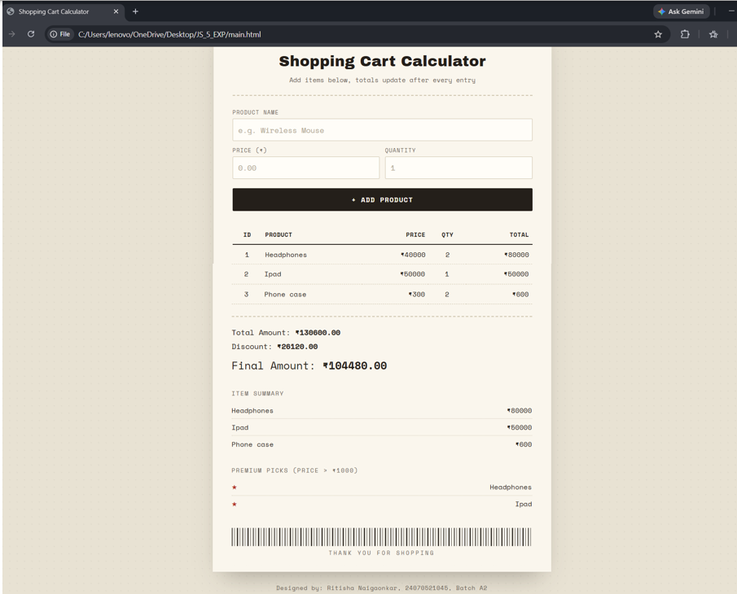
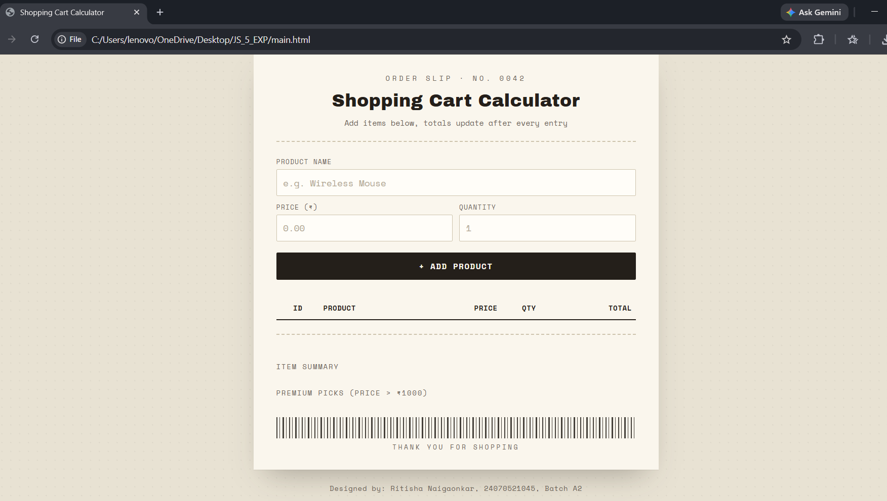
CASE STUDY
5. Case Study Title:
Create an array of numbers and find the maximum and minimum value.
6. Case Study Program Code:
Student Marks Manager (index.html + style.css + script.js) –
index.html:
<!DOCTYPE html>
<html lang="en">
<head>
<meta charset="UTF-8">
<meta name="viewport" content="width=device-width, initial-scale=1.0">
<title>Student Marks Manager</title>

<link rel="preconnect" href="https://fonts.googleapis.com">
<link href="https://fonts.googleapis.com/css2?family=Space+Mono:wght@400;700&family=Archivo+Black&display=swap" rel="stylesheet">

<link rel="stylesheet" href="style.css">
</head>
<body>

<div class="sheet">
<header>
<div class="eyebrow">Case Study &middot; Arrays &amp; Array Methods</div>
<h1>Student Marks Manager</h1>
<div class="tagline">Add student marks below, records update after every entry</div>
</header>

<div class="entry-form">
<div class="field full">
<label for="sname">Student Name</label>
<input type="text" id="sname" placeholder="e.g. Ritisha Naigaonkar">
</div>
<div class="field full">
<label for="marks">Marks (0-100)</label>
<input type="number" id="marks" placeholder="e.g. 78" min="0" max="100">
</div>
</div>

<div class="btn-row">
<button onclick="addStudent()">+ Add Student</button>
<button class="ghost" onclick="removeLast()">&minus; Remove Last</button>
</div>

<table id="marksTable">
<tr>
<th>ID</th>
<th>Name</th>
<th>Marks</th>
<th>Result</th>
</tr>
</table>

<div class="result" id="result"></div>

<h3>Student Summary</h3>
<ul id="summary"></ul>

<h3>Distinction Holders (Marks &gt; 75)</h3>
<ul id="distinction"></ul>

<h3>Case Study &mdash; Highest &amp; Lowest Marks</h3>
<div class="minmax" id="minmax"></div>

<div class="barcode"></div>
<div class="barcode-label">End of Result Sheet</div>
</div>

<footer class="site-footer">
Designed by: Ritisha Naigaonkar, 24070521045, Batch A2
</footer>

<script src="script.js"></script>

</body>
</html>

style.css:
:root {
--paper: #fdfdfb;
--paper-dark: #eef1ee;
--bg: #e3eae6;
--ink: #1e2b23;
--ink-soft: #6d7a72;
--line: #c7d0c9;
--accent-blue: #35608f;
--accent-green: #3b6e4f;
--accent-red: #a63e2e;
--focus: #35608f;
}

* {
box-sizing: border-box;
}

body {
font-family: 'Space Mono', 'Courier New', monospace;
background: var(--bg);
background-image:
radial-gradient(circle at 1px 1px, rgba(0,0,0,0.035) 1px, transparent 0);
background-size: 14px 14px;
color: var(--ink);
min-height: 100vh;
margin: 0;
padding: 48px 16px 72px;
display: flex;
flex-direction: column;
align-items: center;
}

.sheet {
width: 100%;
max-width: 680px;
background: var(--paper);
padding: 40px 40px 32px;
box-shadow:
0 1px 0 rgba(0,0,0,0.05),
0 24px 48px -20px rgba(30, 43, 35, 0.25);
position: relative;
}

header {
text-align: center;
border-bottom: 2px dashed var(--line);
padding-bottom: 20px;
margin-bottom: 24px;
}

.eyebrow {
font-size: 11px;
letter-spacing: 0.3em;
color: var(--accent-blue);
text-transform: uppercase;
margin-bottom: 10px;
}

h1 {
font-family: 'Archivo Black', 'Space Mono', sans-serif;
font-size: 28px;
margin: 0;
letter-spacing: 0.01em;
color: var(--ink);
}

.tagline {
font-size: 12px;
color: var(--ink-soft);
margin-top: 8px;
}

.entry-form {
display: grid;
grid-template-columns: 1fr;
gap: 12px;
margin-bottom: 10px;
}

.field {
display: flex;
flex-direction: column;
gap: 4px;
}

label {
font-size: 10px;
letter-spacing: 0.12em;
text-transform: uppercase;
color: var(--accent-blue);
}

input {
font-family: inherit;
font-size: 14px;
padding: 10px 10px;
width: 100%;
border: 1.5px solid var(--line);
background: #ffffff;
color: var(--ink);
border-radius: 2px;
transition: border-color 0.15s ease, box-shadow 0.15s ease;
}

input::placeholder {
color: #a9b3ac;
}

input:focus {
outline: none;
border-color: var(--focus);
box-shadow: 0 0 0 3px rgba(53, 96, 143, 0.15);
}

.btn-row {
display: flex;
gap: 10px;
margin-top: 4px;
margin-bottom: 8px;
}

button {
font-family: inherit;
font-weight: 700;
font-size: 13px;
letter-spacing: 0.06em;
text-transform: uppercase;
padding: 12px 15px;
flex: 1;
cursor: pointer;
background: var(--ink);
color: var(--paper);
border: none;
border-radius: 2px;
transition: transform 0.1s ease, background 0.15s ease;
}

button:hover {
background: var(--accent-green);
}

button:active {
transform: scale(0.98);
}

button.ghost {
background: #ffffff;
color: var(--ink);
border: 1.5px solid var(--ink);
}

button.ghost:hover {
background: var(--paper-dark);
}

table {
width: 100%;
border-collapse: collapse;
margin-top: 24px;
font-size: 13px;
}

th {
font-size: 11px;
letter-spacing: 0.06em;
text-transform: uppercase;
font-weight: 700;
background: transparent;
color: var(--ink);
border-bottom: 2px solid var(--ink);
border-top: none;
}

th, td {
padding: 9px 6px;
text-align: left;
}

td:nth-child(1),
td:nth-child(3),
th:nth-child(1),
th:nth-child(3) {
text-align: center;
}

td:nth-child(4),
th:nth-child(4) {
text-align: right;
}

table, td {
border: none;
border-bottom: 1px dashed var(--line);
}

tr:last-child td {
border-bottom: 1px dashed var(--line);
}

td.pass {
color: var(--accent-green);
font-weight: 700;
}

td.fail {
color: var(--accent-red);
font-weight: 700;
}

.result {
margin-top: 20px;
padding-top: 16px;
border-top: 2px dashed var(--line);
font-size: 14px;
line-height: 1.9;
}

.result b {
font-weight: 700;
}

.result-final {
font-size: 18px;
margin-top: 4px;
}

h3 {
font-size: 11px;
letter-spacing: 0.12em;
text-transform: uppercase;
color: var(--ink-soft);
margin: 26px 0 8px;
font-weight: 400;
}

ul {
list-style: none;
padding: 0;
margin: 0;
font-size: 13px;
}

ul li {
padding: 6px 0;
border-bottom: 1px dotted var(--line);
display: flex;
justify-content: space-between;
}

ul li:last-child {
border-bottom: none;
}

#distinction li::before {
content: "\2605 ";
color: var(--accent-red);
margin-right: 4px;
}

#distinction li {
justify-content: flex-end;
}

.minmax {
font-size: 13.5px;
line-height: 1.9;
color: var(--ink);
}

.barcode {
margin-top: 28px;
height: 34px;
background: repeating-linear-gradient(
90deg,
var(--ink) 0px, var(--ink) 2px,
transparent 2px, transparent 5px,
var(--ink) 5px, var(--ink) 6px,
transparent 6px, transparent 10px
);
opacity: 0.85;
}

.barcode-label {
text-align: center;
font-size: 10px;
letter-spacing: 0.3em;
color: var(--ink-soft);
margin-top: 6px;
text-transform: uppercase;
}

.site-footer {
width: 100%;
max-width: 680px;
text-align: center;
font-size: 11px;
letter-spacing: 0.06em;
color: var(--ink-soft);
margin-top: 22px;
}

@media (max-width: 480px) {
.sheet {
padding: 28px 20px 24px;
}
}

script.js:
// Array to store student records
let students = [];

// push() - add a new student to the array
function addStudent() {
let name = document.getElementById("sname").value.trim();
let marks = parseFloat(document.getElementById("marks").value);

// Input validation
if (name === "" || isNaN(marks) || marks < 0 || marks > 100) {
alert("Please enter a valid name and marks (0-100)");
return;
}

let student = {
id: students.length + 1,
name: name,
marks: marks
};

students.push(student);

// Clear input fields
document.getElementById("sname").value = "";
document.getElementById("marks").value = "";
document.getElementById("sname").focus();

render();
}

// pop() - remove the last student added
function removeLast() {
if (students.length === 0) {
alert("No students to remove");
return;
}
students.pop();
render();
}

function render() {
renderTable();
renderStats();
renderSummary();
renderDistinction();
renderMinMax();
}

// forEach() - build the table rows
function renderTable() {
let table = document.getElementById("marksTable");

table.innerHTML = `
<tr>
<th>ID</th>
<th>Name</th>
<th>Marks</th>
<th>Result</th>
</tr>
`;

students.forEach(function (student) {
let result = student.marks >= 40 ? "Pass" : "Fail";
let resultClass = student.marks >= 40 ? "pass" : "fail";

table.innerHTML += `
<tr>
<td>${student.id}</td>
<td>${student.name}</td>
<td>${student.marks}</td>
<td class="${resultClass}">${result}</td>
</tr>
`;
});
}

// reduce() - calculate total marks, then derive the average
function renderStats() {
let resultBox = document.getElementById("result");

if (students.length === 0) {
resultBox.innerHTML = "";
return;
}

let totalMarks = students.reduce(function (sum, student) {
return sum + student.marks;
}, 0);

let average = totalMarks / students.length;

resultBox.innerHTML = `
<div>Total Students: <b>${students.length}</b></div>
<div>Total Marks: <b>${totalMarks.toFixed(2)}</b></div>
<div class="result-final">Average Marks: <b>${average.toFixed(2)}</b></div>
`;
}

// map() - create the student summary list
function renderSummary() {
let summary = document.getElementById("summary");
summary.innerHTML = "";

students.map(function (student) {
summary.innerHTML += `
<li><span>${student.name}</span><span>${student.marks} marks</span></li>
`;
});
}

// filter() - find distinction holders (marks > 75)
function renderDistinction() {
let distinction = document.getElementById("distinction");
distinction.innerHTML = "";

let toppers = students.filter(function (student) {
return student.marks > 75;
});

toppers.forEach(function (student) {
distinction.innerHTML += `
<li><span>${student.name}</span></li>
`;
});
}

// Case Study: create an array of numbers (marks) and find the max and min value
function renderMinMax() {
let minmax = document.getElementById("minmax");

if (students.length === 0) {
minmax.innerHTML = "";
return;
}

// Build a plain array of numbers from the student records
let marksArray = students.map(function (student) {
return student.marks;
});

let highest = Math.max(...marksArray);
let lowest = Math.min(...marksArray);

let topper = students.find(function (student) {
return student.marks === highest;
});
let bottomer = students.find(function (student) {
return student.marks === lowest;
});

minmax.innerHTML = `
<div>Highest Marks (${highest}): <b>${topper.name}</b></div>
<div>Lowest Marks (${lowest}): <b>${bottomer.name}</b></div>
`;
}

7. Output:
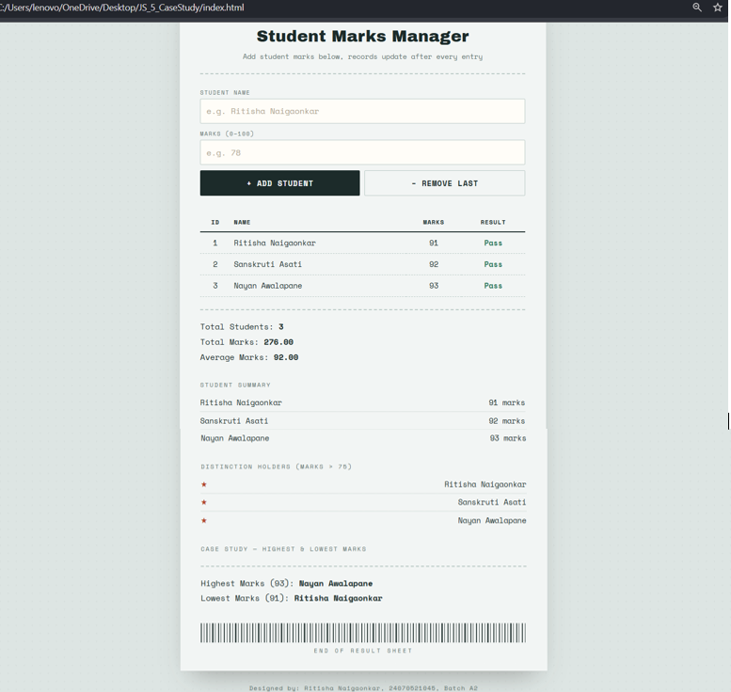
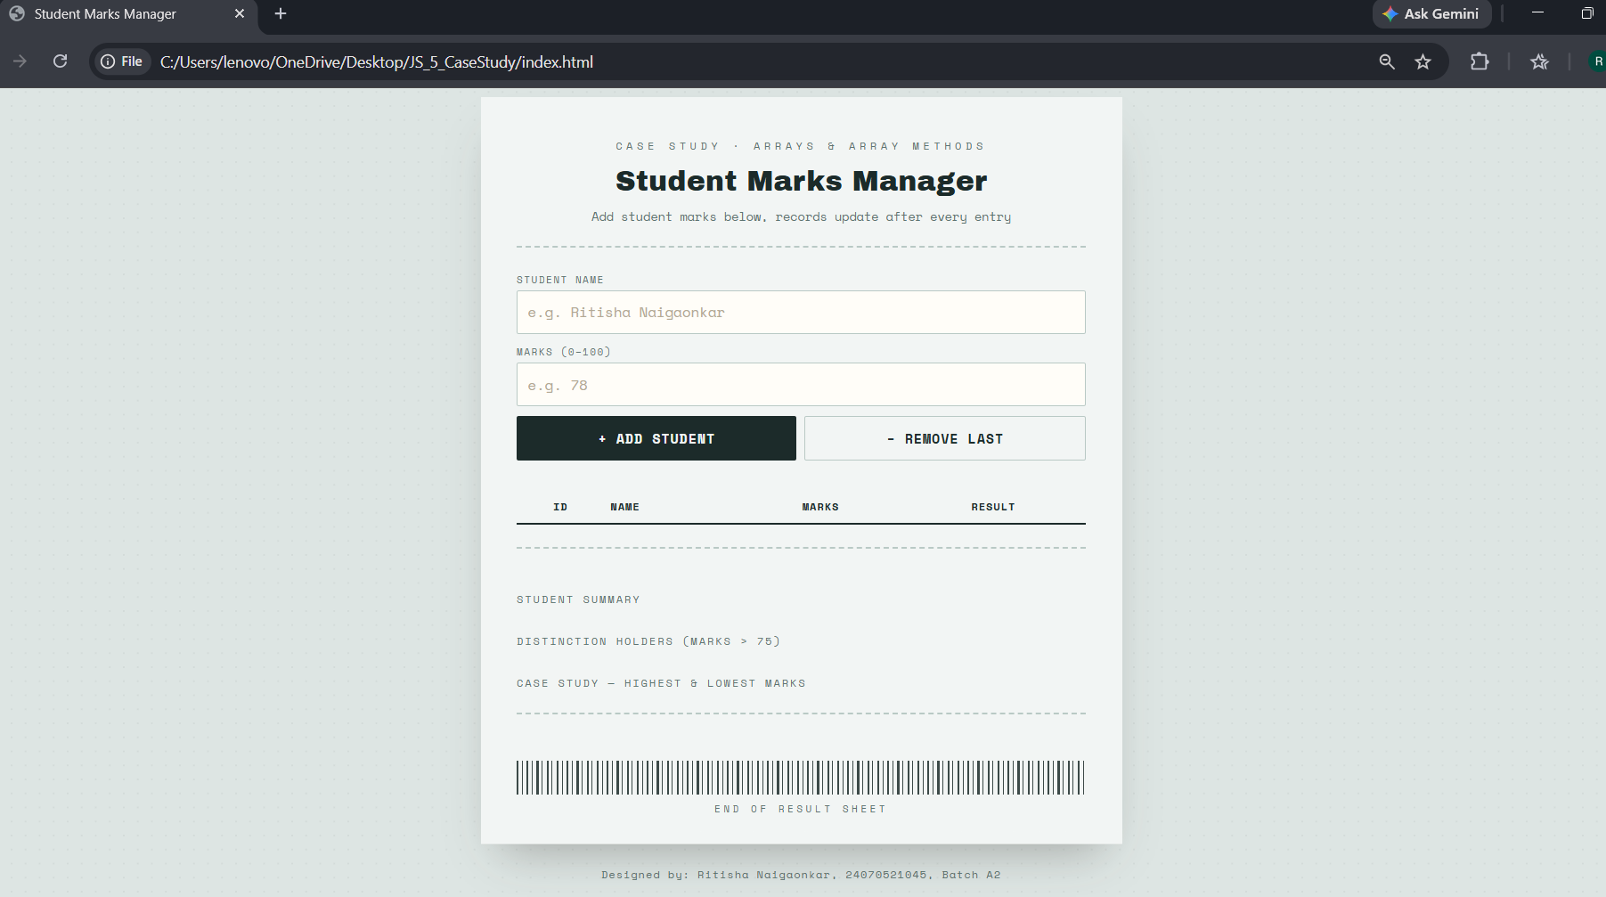
8. Result/Conclusion:
Thus the functioning of Arrays and Loops in JavaScript was studied and implemented using array methods such as push(), pop(), map(), filter(), reduce() and forEach(). The case study program to create an array of numbers and find the maximum and minimum value was also implemented, and the desired output was verified.
Ritisha Naigaonkar, 24070521045, V-A(A2)

